Selenium WebDriver Introduction and Installation
Course: Selenium Web Automation Training
Module: Week 1 - Selenium WebDriver Basics & Setup
- Introduction to Selenium 4 WebDriver
Selenium 4.x is the newer version of Selenium. The dependency on the JSON Wire Protocol is removed and it now uses the W3C WebDriver standard. The steps of the working of the webdriver are given below.
- Write the automation test code in a programming language.
- The Selenium Client Library receives the commands.
- Selenium converts the commands according to the W3C WebDriver standard.
- The commands are sent to the browser driver.
- The driver communicates with the browser using standardized commands.
- The browser performs the requested action.
- The response follows the same standardized protocol back to your script.
Feature | Selenium 3.x | Selenium 4.x
Core Architecture | Primarily based on JSON Wire Protocol | Fully based on W3C WebDriver Protocol
Driver Management | Requires manual download and path setup for executable binaries (ChromeDriver, GeckoDriver, etc.) or external libraries. | Selenium Manager is built-in; it automatically downloads and manages the correct driver binaries.
Locators | Standard locators only (id, name, xpath, cssSelector) | Introduces Relative Locators (above, below, toLeftof, toRightof, near)
Browser Control | Limited to standard UI automation. | Deep browser interaction via Chrome DevTools Protocol (CDP) and WebDriver BiDi (network interception, performance metrics, console logs).
Selenium Grid | Complex hub-and-node setup; outdated UI. | Deep browser interaction via Chrome DevTools Protocol (CDP) and WebDriver BiDi (network interception, performance metrics, console logs).

- Selenium WebDriver architecture
Browser
W3C WebDriver Protocol
Test Script

Selenium Client Library
Browser Driver

- Test Automation Script
This is the code written by the automation tester.
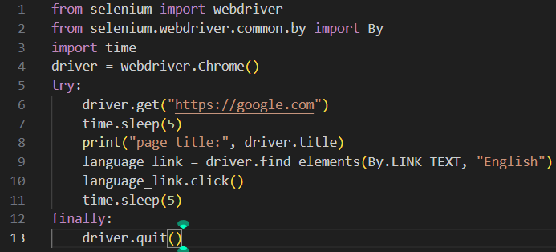
Test script contains some commands such as get(), find_element(), click(), send_keys(), clear(), quit(). However, the browser cannot directly understand these Python commands. Therefore, the commands must pass through the Selenium WebDriver architecture.
- Selenium Client Library
The Selenium Client Library is language-specific.
Programming Language | Selenium Binding
Python | Selenium Python
Java | Selenium Java
C# | Selenium .NET
JavaScript | Selenium JavaScript
Ruby | Selenium Ruby

The Selenium Python library processes this command and converts it into a WebDriver request.
Web Driver Interface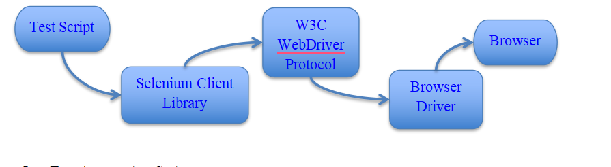
Remote Web Driver Class
Implements

Chrome Driver
Geko Driver
Edge Driver

WebElement Interface
Uses By to return

TargetLocator / Navigation / Options
Exposes Sub-APIs

WebDriver is the main interface in Selenium. It defines common methods for controlling a browser, such as: driver.get(), driver.quit(), driver.find_element(), driver.back()
RemoteWebDriver is an important implementation that provides much of the core WebDriver functionality. It handles commands sent from your Selenium code to the browser.

Browser-Specific Drivers are ChromeDriver, FirefoxDriver, EdgeDriver, SafariDriver. These drivers provide browser-specific implementations.
The By class is used to specify how Selenium should locate an element.

When Selenium finds an element on a webpage, it returns a WebElement. Some important APIs exposed by WebDriver are: TargetLocator, Navigation, Options.

TargetLocator is used for switching between Frames, Alerts, Windows, Tabs

Navigation is used for browser navigation:

Options are used for browser configuration and management. That include Cookies, Window size, Browser settings

- W3C WebDriver protocol
The W3C WebDriver Protocol is a standardized set of rules that defines how Selenium communicates with a web browser. W3C stands for World Wide Web Consortium. It is the organization that develops web standards. Selenium Python code cannot directly communicate with Chrome or Firefox using Python commands. So the W3C WebDriver protocol is needed. The WebDriver protocol communicates using HTTP requests. A Selenium command is converted into a request containing information about the action.
For example the python code is: driver.get("https://example.com")
Selenium sends something like: POST /session/{session-id}/url
with data containing:
{
"url": "https://example.com"
}
The browser driver processes the request and returns a response.
- Browser driver
A Browser Driver is a software component that acts as a bridge between Selenium WebDriver and a web browser. It receives commands using the W3C WebDriver Protocol and communicates those commands to the actual browser.WebDriver provides the automation commands. Browser Driver helps the specific browser execute those commands.
- Web brouser
A web browser is the actual application where the website runs and Selenium performs automation. Google Chrome, Mozilla Firefox, Microsoft Edge, Safari
- Software’s requires in this course

Essential Software
- Python: Programming language used for writing automation scripts.
- Python IDE / Code Editor:Visual Studio Code or PyCharm
- Selenium WebDriver: Python library used for browser automation.
- Web Browser: Google Chrome, Mozilla Firefox, Microsoft Edge etc.
- Browser Driver / Selenium Manager: Selenium 4 can automatically manage compatible browser drivers using Selenium Manager.

Additional Software/Tools
- RIDE: Robot Framework IDE.
- Robot Framework
- SeleniumLibrary with Robot Framework
- Jenkins: Used for Continuous Integration (CI) and automated test execution.
- Git: Used for version control and GitHub integration.

- Selenium WebDriver Installation with Python 3
Below video link is there.
Python Installation
https://drive.google.com/drive/folders/1TFufZPzEX__EC0O7cbBkANaoy7RW6Sw?usp=sharing
Selenium Installation
https://drive.google.com/drive/folders/1kPcFRtCHnXAmVMtAF9WgYPEklaqOlK5?usp=drive_link

To install Selenium just type pip install selenium in the command prompt and press enter.
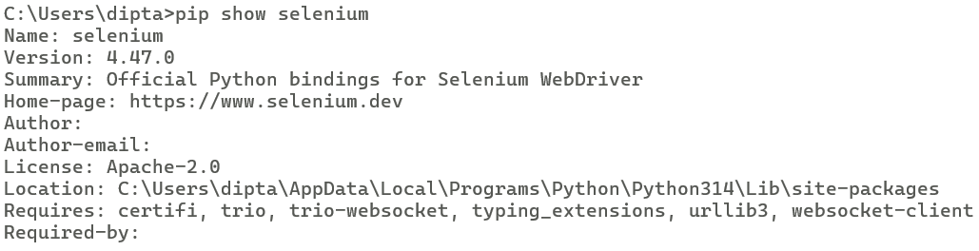
To check the version of the Selenium type pip show selenium in the command prompt and press enter.

- How To Set Drivers In System Path - Windows
This manual method is mainly useful for older Selenium setups. Modern Selenium 4 can often manage drivers automatically through Selenium Manager.
- Download the browser driver (Chrome = ChromeDriver, Firefox = GeckoDriver, Edge = EdgeDriver
- Extract the downloaded driver file
- Create a folder for drivers, for example: C:\WebDrivers
- Move the driver executable into that folder. Example: C:\WebDrivers\chromedriver.exe
- Open Windows Search and search for: Environment Variables
- Click Edit the system environment variables.
- Click Environment Variables.
- Under System Variables, select Path.
- Click Edit.
- Click New and add: C:\WebDrivers
- Click OK to save all changes.
- Close and reopen the Command Prompt or VS Code terminal.
- Verify the driver: chromedriver --version

- Running the test in different browser (Chrome, Edge,Fire fox in windows)
Selenium allows the same test script to run on different browsers such as Chrome, Microsoft Edge, and Firefox.

1. Google Chrome
from selenium import webdriver
driver = webdriver.Chrome()
driver.get("https://www.google.com")
driver.quit()

2. Microsoft Edge
from selenium import webdriver
driver = webdriver.Edge()
driver.get("https://www.google.com")
driver.quit()

3. Mozilla Firefox
from selenium import webdriver
driver = webdriver.Firefox()
driver.get("https://www.google.com")
driver.quit()

